MINI PROJECT

(2021-2022)

**“FACE RECOGNITION ATTENDANCE SYSTEM”**

PROJECT REPORT

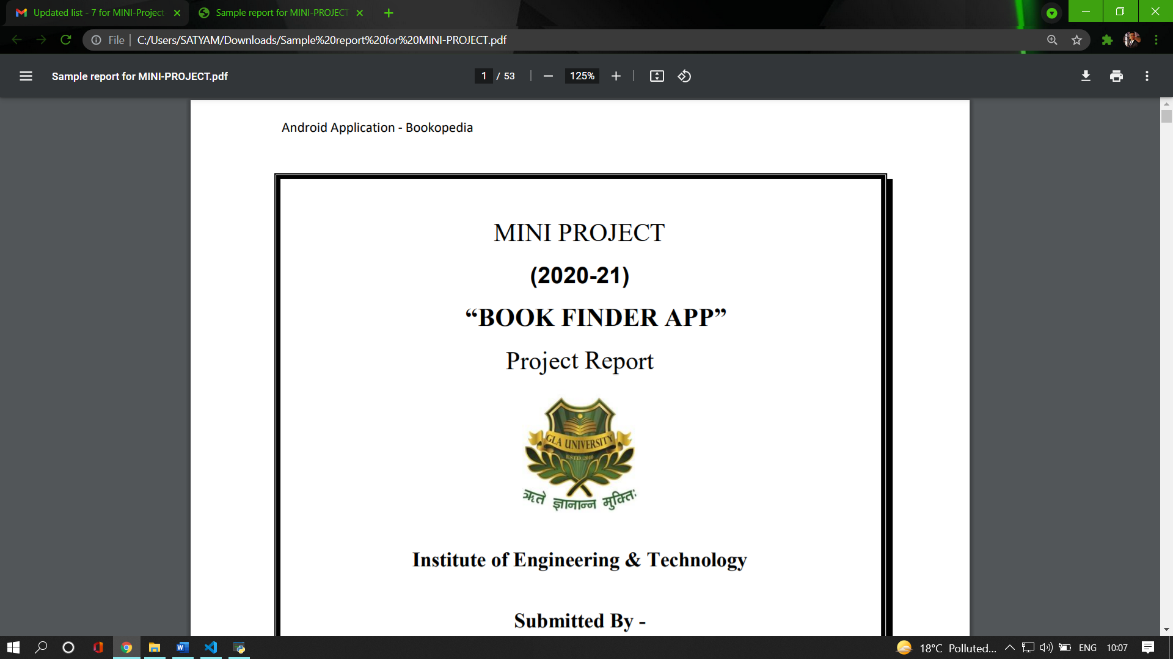

Institute of Engineering & Technology

**Submitted By –**

Satyam (191500730)

**Under the Supervision Of -**

Mr. Amir Khan Technical Trainer

**Department of Computer Engineering & Applications**

Department of Computer Engineering and Applications GLA University, 17 km. Stone NH#2, Mathura-Delhi Road, Chaumuha, Mathura – 281406 U.P (India)

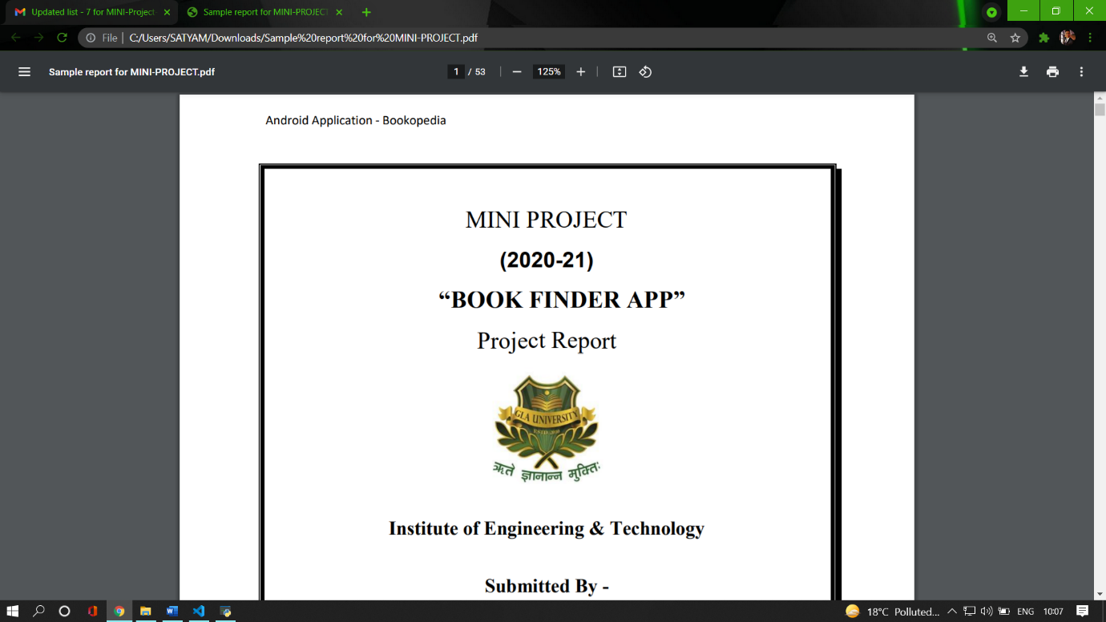

**Declaration**

I hereby declare that the work which is being presented in the Bachelor of technology. Project **“Face Recognition Attendance System”**, in partial fulfillment of the requirements for the award of the Bachelor of Technology in Computer Science and Engineering and submitted to the Department of Computer Engineering and Applications of GLA University, Mathura, is an authentic record of my own work carried under the supervision of **Mr. Amir Khan**, Technical Trainer, Dept. of **CEA,GLA University**.

The contents of this project report, in full or in parts, have not been submitted to any other Institute or University for the award of any degree.

Sign: Satyam

Name of Candidate: Satyam

University Roll No.:191500730



Department of Computer Engineering and Applications GLA University, 17 km. Stone NH#2, Mathura-Delhi Road, Chaumuha, Mathura – 281406 U.P (India)

**Certificate**

This is to certify that the project entitled “Face recognition Attendance System”, carried out in Mini Project – I Lab, is a bonafide work by Satyam and is submitted in partial fulfillment of the requirements for the award of the degree Bachelor of Technology (Computer Science & Engineering).

Signature of Supervisor:

Name of Supervisor: Mr. Amir Khan

Date:

**Training Certificates**

**Satyam:**



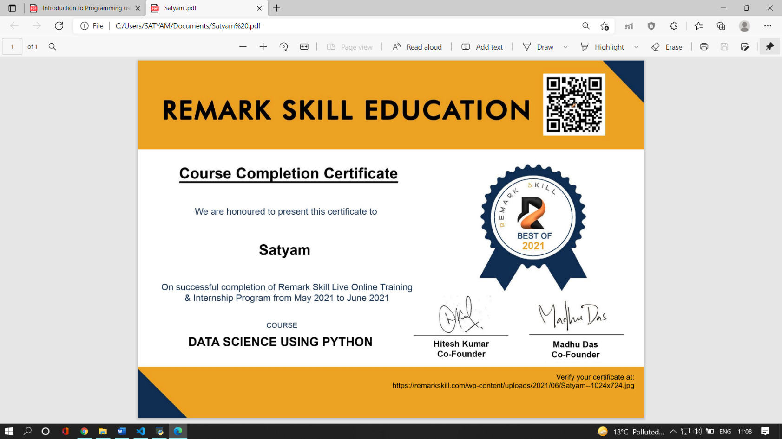



Department of Computer Engineering and Applications GLA University, 17 km. Stone NH#2, Mathura-Delhi Road, Chaumuha, Mathura – 281406 U.P (India)

**ACKNOWLEDGEMENT**

Presenting the ascribed project paper report in this very simple and official form, I would like to place my deep gratitude to GLA University for providing me the instructor Mr Amir Khan, my technical trainer and supervisor.

He has been helping me since Day 1 in this project. He provided me with the roadmap, the basic guidelines explaining on how to work on the project. He has been conducting regular meeting to check the progress of the project and providing me with the resources related to the project. Without his help, I wouldn’t have been able to complete this project.

And at last but not the least i would like to thank my dear parents for helping me to grab this opportunity to get trained and also my colleagues who helped me find resources during the training.

Thanking you

Sign: Satyam

Name of Candidate: Satyam

University Roll No.:191500730

**ABSTRACT**

In this project, I am creating an application, basically an automatic attendance taking by face recognition which i have named Face Recognition Attendance System. This application will provide us a platform to take attendance automatically by face recognition. The teacher, who are using this application for taking attendance, first time save all the details of student like student course, student id , student roll number , phone number etc . and most important thing is to save the face image samples so that face detector detect the face and compare with face image samples if match than that student will present automatically and after this data will save in database and teacher can see on his portal easily.

The app is suitable in the present scenario as the world is being faster then why not the attendance system . On the profile of the user, one can easily view the attendance status. The app will be completely efficient.

App ecosystem is diversing and is changing people’s life all over the world. Furthermore designing solutions for the problems that we may face in future is essential.

**CONTENTS**

Cover Page …………………………………………………………………… i

Declaration ……………………………………………………………………ii

Certificate ……………………………………………………………………..iii

Training Certificate………………………………………………..………….iv

Acknowledgement ………………………………………………………….vii

Abstract ……………………………………………………………………..viii

Content …………………………………………………………………….….ix

List Of figures ………………………………………………………………….xi

List Of tables ………………………………………………………………..xii

Chapter 1Introduction……………………………………..……..………………1

• 1.1 Context………………………………………………………………...1

• 1.2 Motivation…………………………………………………………......1

• 1.3 Objective……………………………………………………………….1

• 1.4 Existing System……………………………………………………......2

• 1.5 Sources…………………………………………………………………2

Chapter 2 Software Requirement Analysis…………………………………….....4

• 2.1 Importance Of attendance ……………..……………………….....4

• 2.2 Problem Statement……………………………………………………..5

• 2.3 Hardware and Software Requirements….…………………...6

• 2.4 Modules and Functionalities………………………….………………..6

Chapter 3 Software Design………………………………………………………..8

• 3.1 Use Case Diagram………………………………………………….…..8

• 3.2 Data Flow Diagram…………………………………………….………11

• 3.3 Sequence Diagram……………………………………………..……….12

Chapter 4 Technology Used………………………………………………………13

• 4.1 Android……………………………………………………………...….13

• 4.2 Version of Android……………………………………………………..14

• 4.3 Tools and Languages………………………………………...…………15

• 4.4 Basic Terminology……………………………………………………..16

Chapter 5 Implementation and User Interface…………………………………….19

• 5.1 Implementation of Bookopedia…………………………………...……19

• 5.2 User Interface…………………………………………………………..23

Chapter 6 Testing…………………………………………………………….……33

• 6.1 Installation Testing…………………………………………….……….33

• 6.2 Unit Testing…………………………………………………….………34

• 6.3 User Testing……………………………………………………………37

• 6.4 Performance Testing…………………………………………..……… 38

• 6.5 Compatibility Testing………………………………………...………. 39

Chapter 7 Conclusion……………………………………………………………40 References……………………………………………………….……………………….4

**LIST OF FIGURES**

1. Existing System……………………………………………………………2

2. Use Case Diagram…………………………………………………………9

3. Data Flow Diagram………………………………………………………..11

4. Sequence Diagram…………………………………………………………12

5. Android Kit-Kat……………………………………………………………14

6. Flow Chart for User………………………………………………………..21

7. Splash Screen………………………………………………………………23

8. Register Page………………………………………………………………23

9. Login Page…………………………………………………………………24

10. Forget Password…………………………………………………………...24

11.Navigation Drawer………………………………………………………...25

12.Dashboard Fragment………………………………………………………26

13. Profile Page...……………………………………………………………...27

14. Favourite Page……………………………………………………………..28

15.Sign-out Page…..…………………………………………………………..28

16.About App Page……………………………………………………………29

17.FAQ Page…………………………………………………………………..29

18.Search Book Page…………………………………………………………. 30

19. Description Page…………………………………………………………. 30

20. Book List…………………………………………………………………..31

21. Book added to Favourite…………………………………………………..31 22.Favourites…………………………………………………………………..32

23. Book removed from Favourite……………………………………………

**LIST OF TABLES**

1. Version of Android…………………………………………………………14

2. Unit testing of Bookopedia……………………………………….………..34

**CHAPTER -1**

**INTRODUTION**

**1.3 OBJECTIVE**

Instead of using the conventional methods, this proposed system aims to develop an automated system that records the student's attendance by using facial recognition technology. The main objective of this work is to make the attendance marking and management system efficient, time saving, simple and easy.

**1.2 MOTIVATION**

The main motivation for this project was the slow and inefficient traditional manual attendance system. So, why not make it automated fast and much efficiently. Also, such face detection techniques are in use by the department of criminal investigation where the usage of CCYV footages and detecting the faces from the crime scene and comparing them with criminal database to recognize them. It is also becoming as a feature of daily life in China. Where authorities are using it on the streets, in the subway stations, and at airport.

**1.1 CONTEXT**

This machine learning application “FACE RECOGNITION ATTENDANCE SYSTEM” has been submitted in partial fulfilment of the requirements for the award of the degree of Bachelor of Technology in Computer Science and Engineering at GLA University, Mathura supervised by Mr. Amir Khan. This project has been completed approximately three months and has been executed in modules, meetings have been organised to check the progress of the work and for instructions and guidelines.

**1.4 EXISTING SYSTEM**

In the Fingerprint based existing attendance system, a portable fingerprint device need to be configured with the students fingerprint earlier. Later either during the lecture hours or before, the student needs to record the fingerprint on the configured device to ensure their attendance for the day. The problem with this approach is that during the lecture time it may distract the attention of the students.

The facial recognition technology can be used in recording the attendance through a high-resolution digital camera that detects and recognizes the faces of the students and the machine compares the recognized face with students’ face images stored in the database. Once the face of the student is matched with the stored image, then the attendance is marked in attendance database for further calculation. If the captured image doesn't match with the students' face present in the database then this image is stored as a new image onto the database. In this system, there are possibilities for the camera to not to capture the image properly or it may miss some of the students from capturing.

**1.5 SOURCES**

For this project I use different sites or YouTube videos

YouTube video link:

<https://youtu.be/YX8BzK_LU0E>

<https://youtu.be/uwJltCOrpEI>

<https://youtu.be/sz25xxF_AVE>

web sites:

<https://github.com/kmhmubin/Face-Recognition-Attendance-System>

<https://medium.com/@rishabh.rk1705/automatic-facial-recognition-based-attendance-system-bea3be8003fe>

<https://pythonawesome.com/a-face-recognition-attendance-system-with-python/>

**CHAPTER -2**

**SOFTWARE REQUIREMENT ANALYSIS**

**2.1 IMPORTANCE OF ATTENDANCE**

With regular attendance for school, students gain academic, personal, and professional benefits. We all know that with regular attendance for school, students learn every day and do not have any backlogs. With no backlogs, they will have to study less.

Importance of attendance is not only for student but also for employee who are working in industry. So it is important for them also.

**2.2 PROBLEM STATEMENT**

Up to date, attendance system has been taken manually which causing time waste, paper work, besides it is inaccurate. Face recognition technology can be utilized to build an automated attendance system that makes counting and identifying students much easier and convenient. Face occlusions, face scaling, and posture are still important problems in such systems.

**2.3 HARWARE AND SOFTWARE REQUIREMENTS**

•Language Used: Python

• Database: MySql

• User Interface Design: Graphical user interface

• Processor : intel Pentium processor or other 1GHz or more

• Operating System : window 7 or above , linux, mac os x

• RAM : minimum 128MB RAM or above

• Hardware Devices: minimum 32MB graphic card RAM or above

• Hard disk : space of 500GB or above

**2.4 MODULES AND FUNCTIONALITIES**

**1.Login Page:**

This is the first page for login the user and after that user will enter into main page.

**2. MAIN PAGE:**

This is the main screen where user interact with the app, we can see the name of the application and eight different sections.

3.Student Details

3.Train Data

4.Attendance

5.Face Detector

6.Photos

7.Developer

8.Help Desk

9.Exit

**2.Student Details:**

After entering on Student Details section. We see the student details like student id, student roll number, mobile number , photo samples etc.

And also we can delete and update student details in this section.

And also we take photo samples as student details.

**3.Train Data:**

This section train the data which are saved in data folder by using student details section.

**4.Attendance:**

This section has the attendance data which are saved by student details section data stored in database

**5.Face Detector:**

This section detect the face image.

**6.Photos:**

This section have photos sample

**7.Developer:**

Here it provide developer section who develop this app for enquiry

**8.Help Desk:**

This section help section if user face any problem this section provide help

**9.Exit:**

This section just to exit from main section

**CHAPTEER -3**

**SOFTWARE DESIGN**

**3.1 USE CASE DIAGRAM:**